Name: Patrick Hewitt
Student ID: (removed for the public copy)

Instructions: Use a computer application or paper/pencil to create a wireframe for a sample page on your web site that clearly shows the header, navigation, content, and footer areas. If you are using a graphics application to create a wireframe and save as a .gif or .jpg file and insert them below. If you are using paper/pencil please either scan your sketches in or take pictures with your cell phone and insert them below. Images that are not clear and easy to read will lose points. Review the rubrics to find out what info is required to be included in the wireframe. Below is an example. Do not add color to the wireframe.

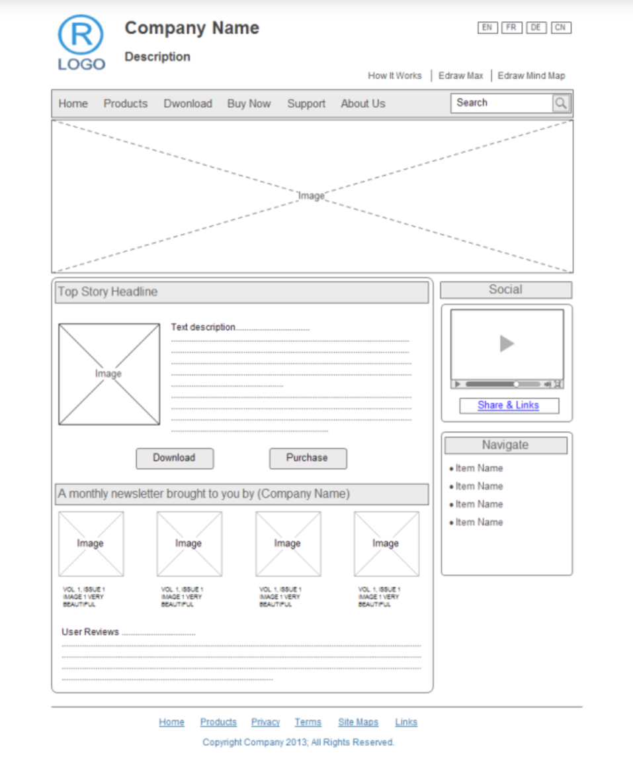

Bench Notes — home page wireframe (large display view)
This home page layout is the template reused on all five pages — How It Decides, FAQ, About, and Contact keep the same header, navigation, and footer, and only the contents of <main> change.
